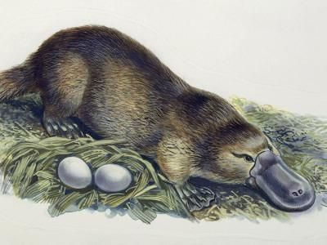
DUCK BILLED PLATYPUS IMAGE

